Total Surface Area

Definition
# Source: AI Source: Provided by: [Data Path: Persons Table -> ID Column: 1, Name_En Column: Motasem Essam] -> From: [ChatGPT] on [7/20/2026]
Total surface area is the sum of the areas of all external surfaces of a three-dimensional solid.
In simple terms:
Total surface area measures the entire outside surface of a 3D object, including all of its bases and lateral surfaces.
$$\boxed{\text{Total Surface Area}=\text{Area of All External Surfaces}}$$
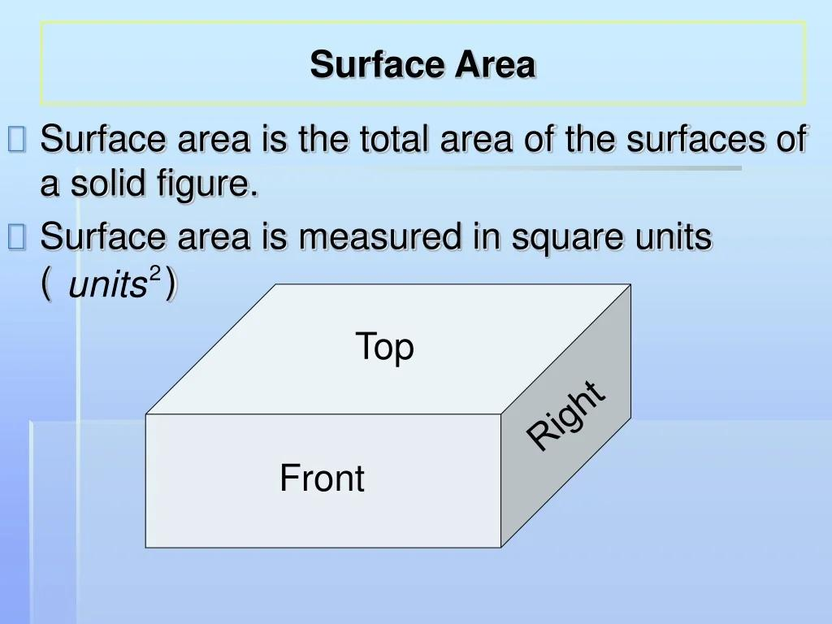
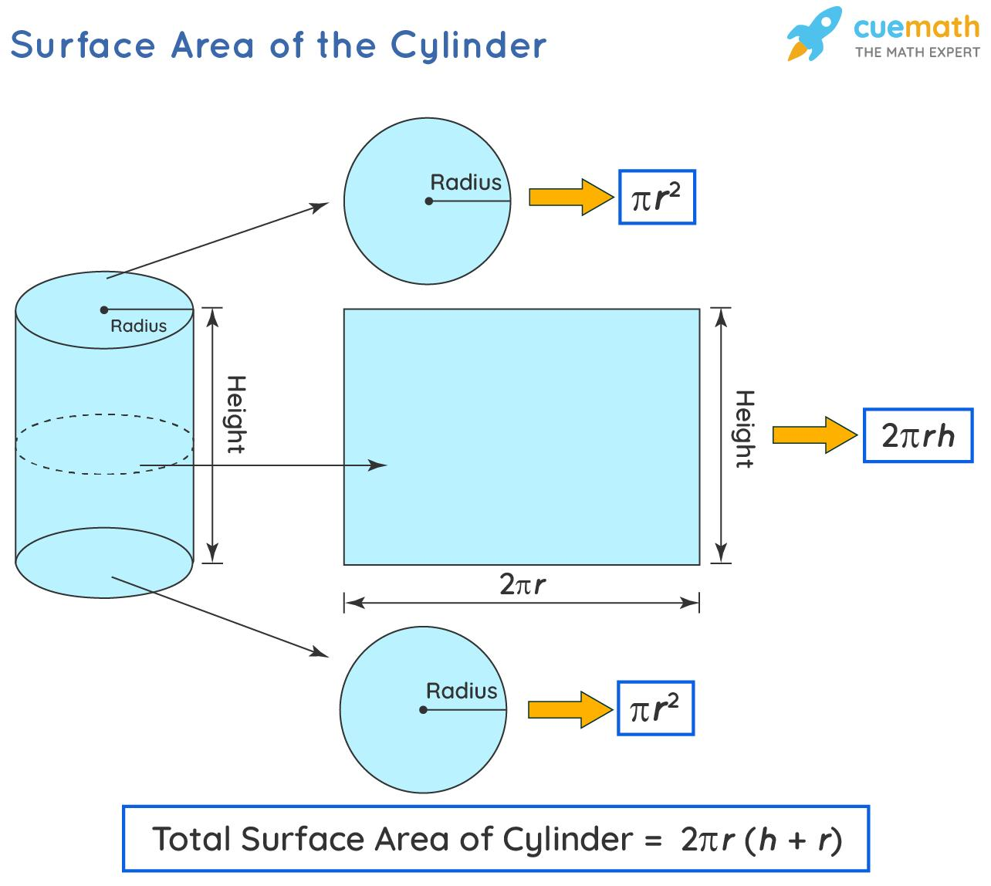
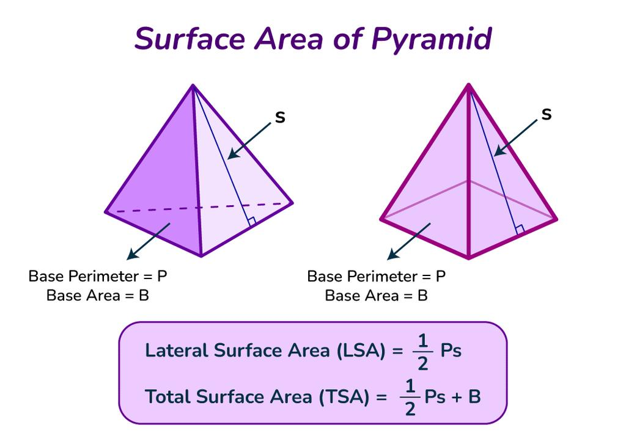
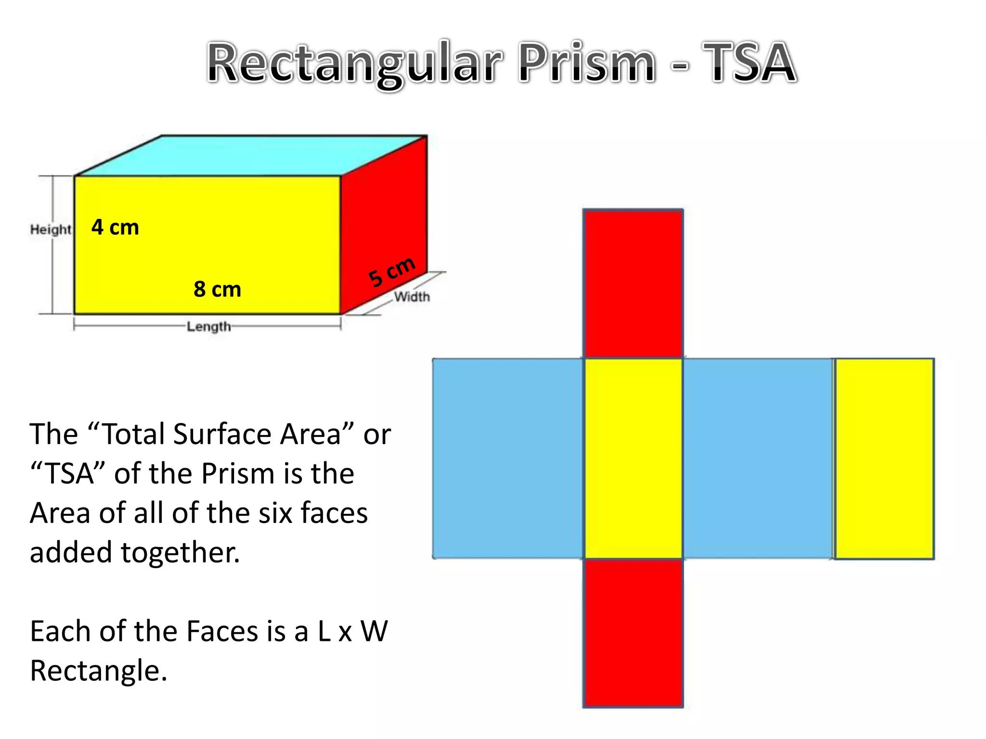

Characteristics
# Source: AI Source: Provided by: [Data Path: Persons Table -> ID Column: 1, Name_En Column: Motasem Essam] -> From: [ChatGPT] on [7/20/2026]
Total surface area:
- Applies primarily to three-dimensional solids.
- Includes all external faces or surfaces.
- Includes the base or bases.
- Includes the lateral surfaces.
- Is a two-dimensional measurement.
- Is measured in square units.
$$\boxed{\left[SA\right]=L^{2}}$$
The general relationship is:
$$\boxed{SA=LA+\text{Area of Base(s)}}$$

Total Surface Area of Common Solids

1. Cube
# Source: AI Source: Provided by: [Data Path: Persons Table -> ID Column: 1, Name_En Column: Motasem Essam] -> From: [ChatGPT] on [7/20/2026]
For a cube with side length $s$:
$$\boxed{SA=6s^{2}}$$
because a cube has six congruent square faces.
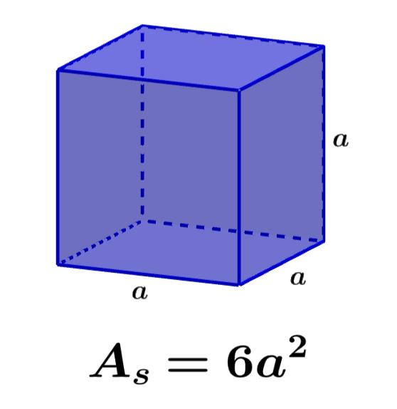
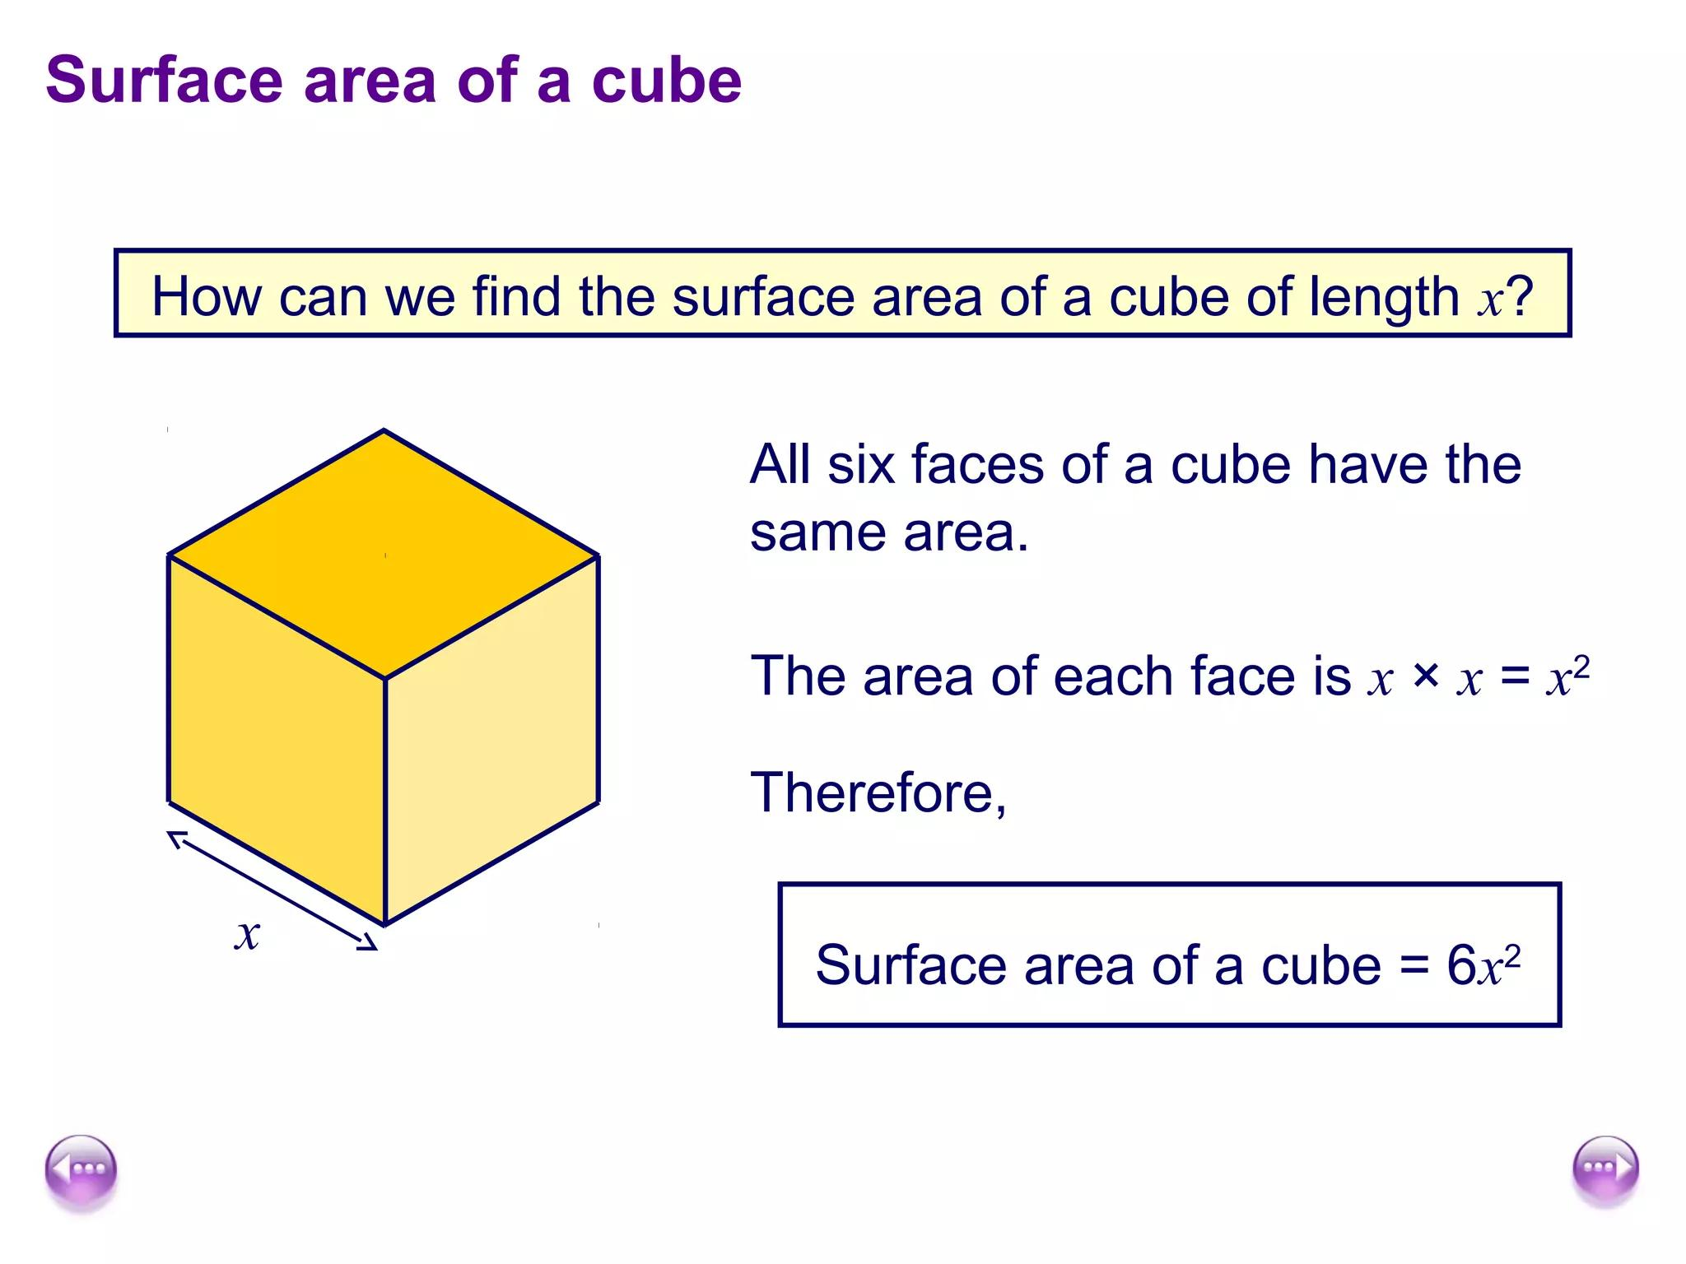
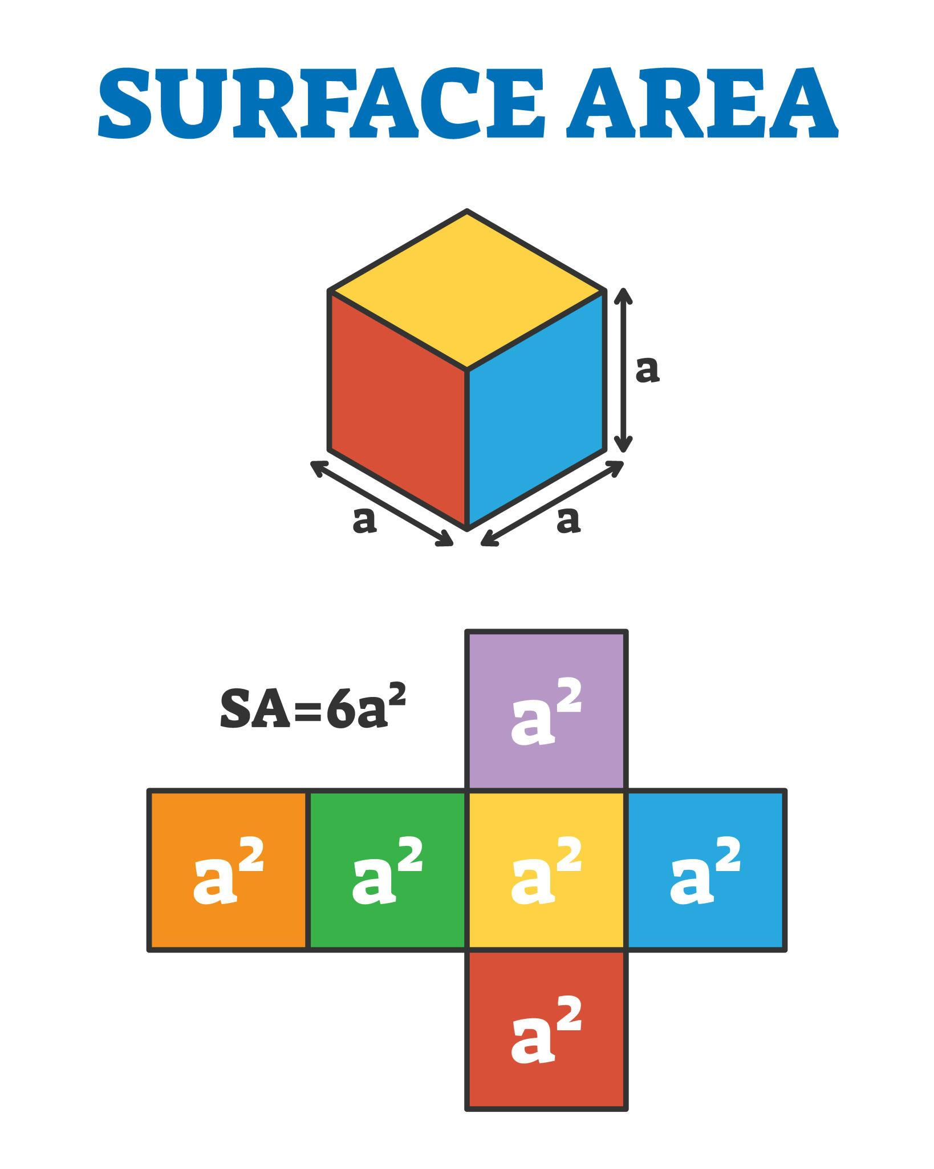
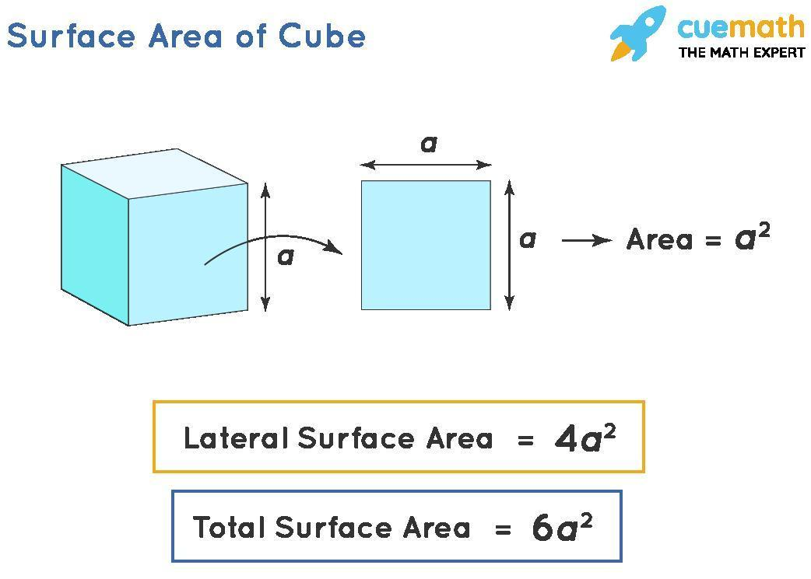
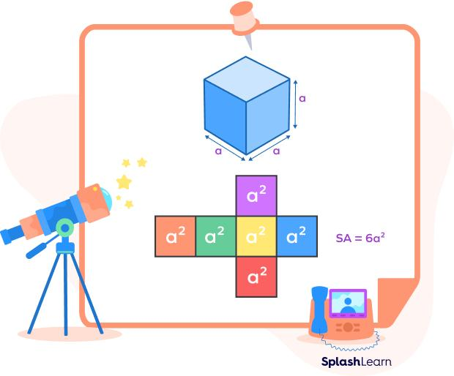

2. Rectangular Prism
# Source: AI Source: Provided by: [Data Path: Persons Table -> ID Column: 1, Name_En Column: Motasem Essam] -> From: [ChatGPT] on [7/20/2026]
For length $l$, width $w$, and height $h$:
$$\boxed{SA=2\left(lw+lh+wh\right)}$$
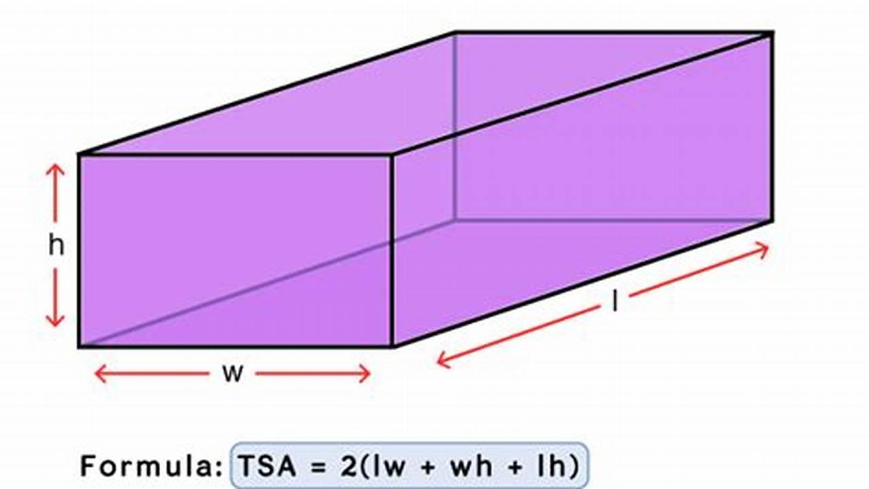
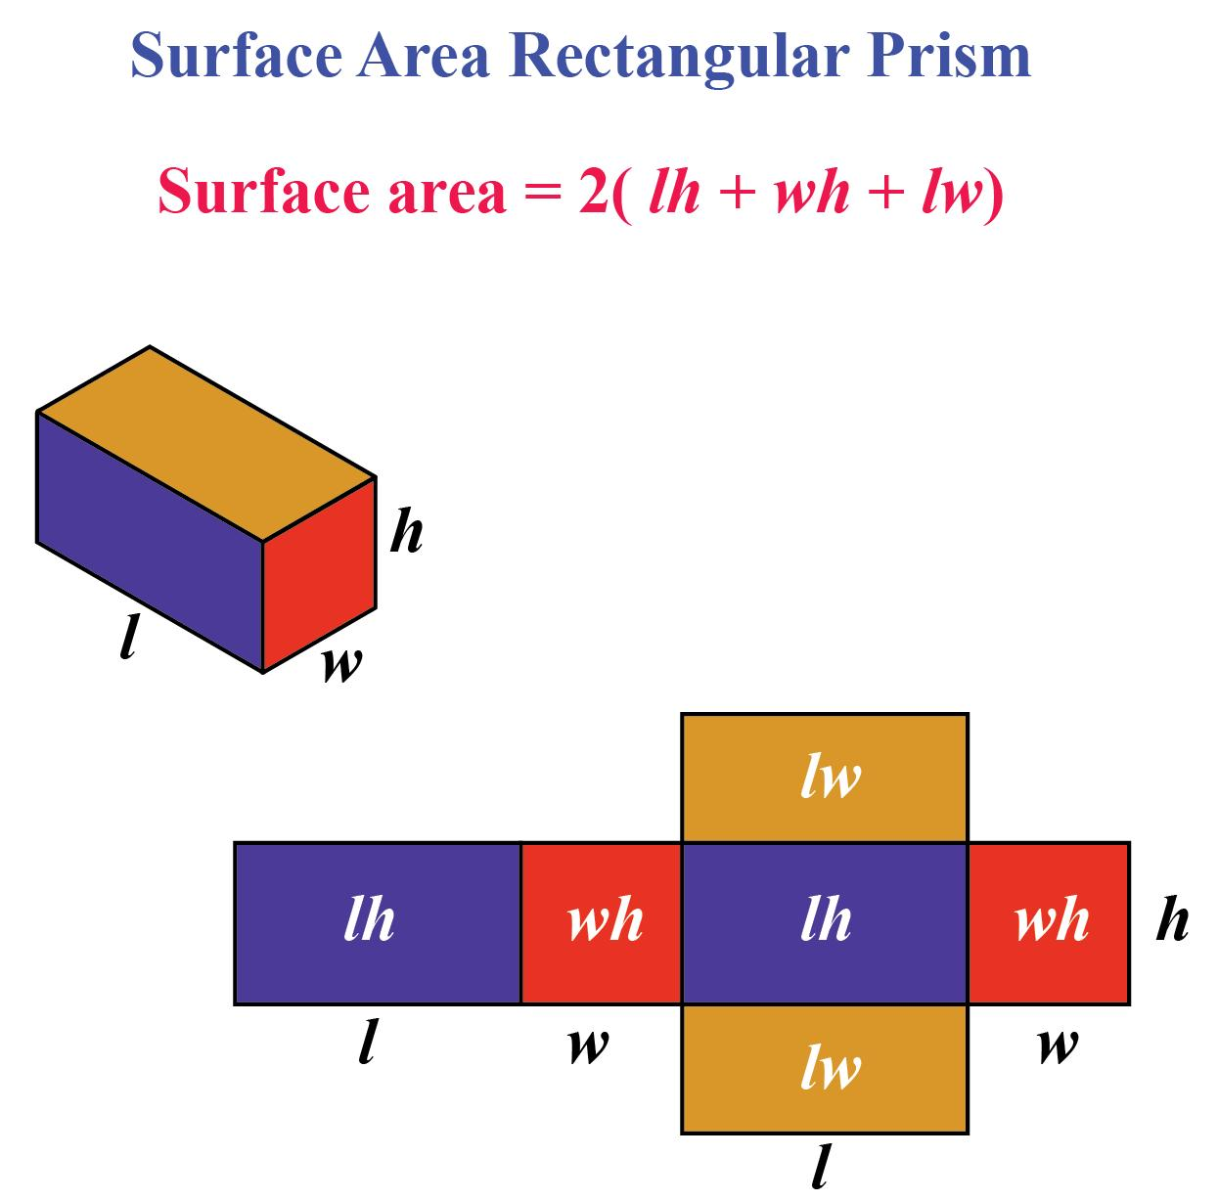
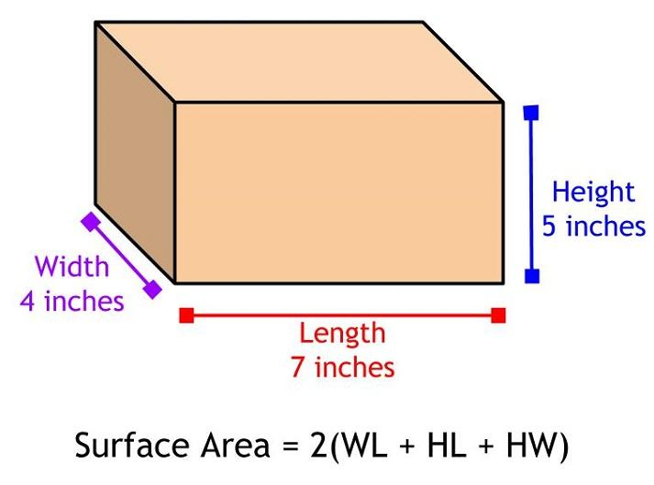
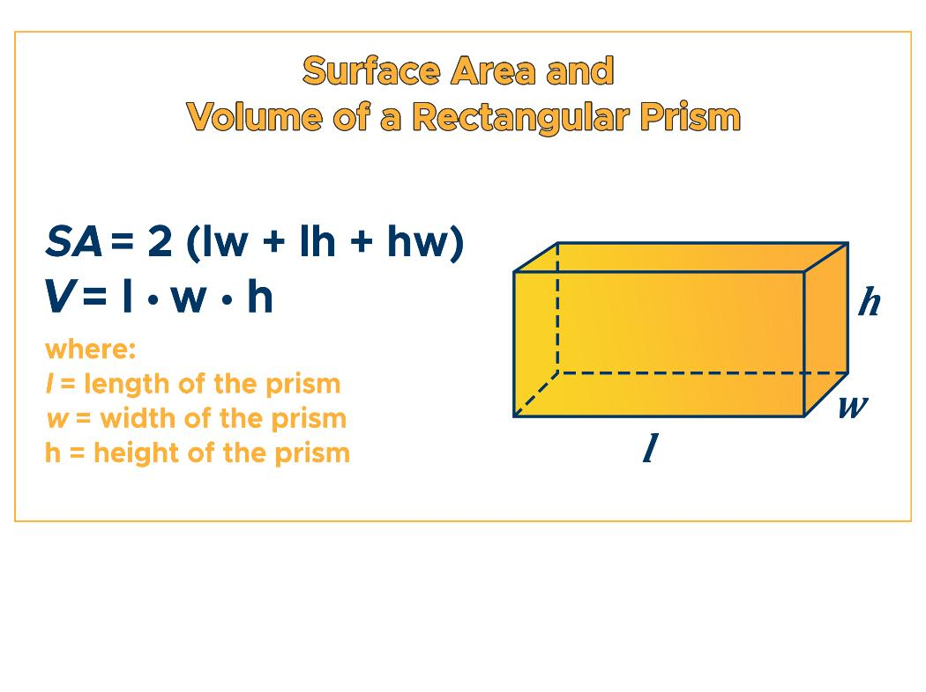
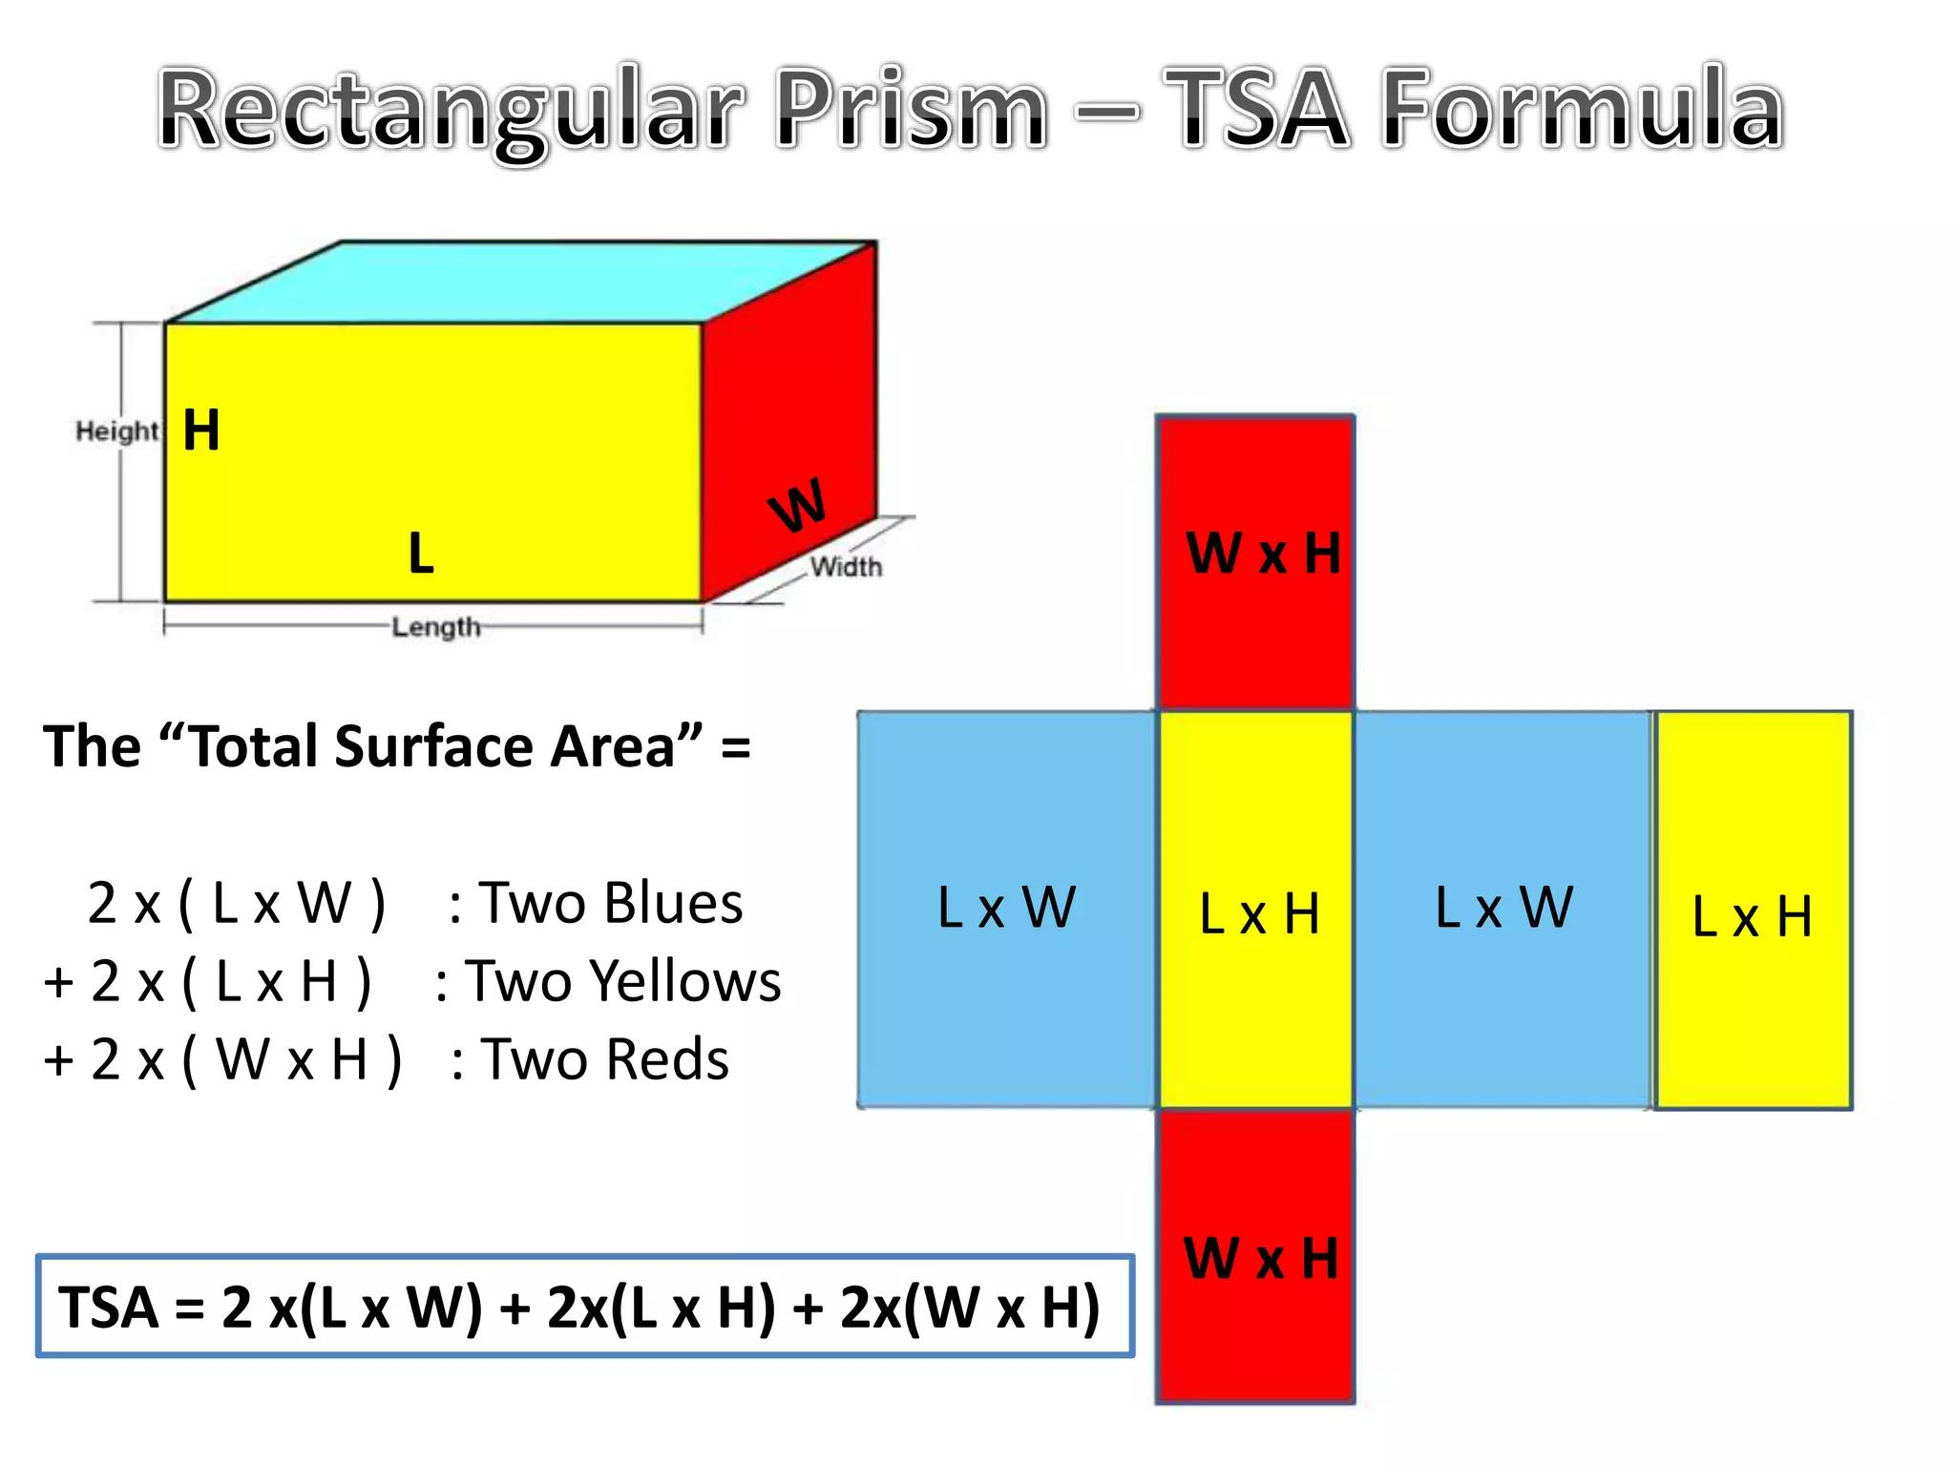
The six faces consist of three pairs:
$$lw, lh, wh$$
so:
$$SA=2lw+2lh+2wh$$

3. Cylinder
# Source: AI Source: Provided by: [Data Path: Persons Table -> ID Column: 1, Name_En Column: Motasem Essam] -> From: [ChatGPT] on [7/20/2026]
For radius $r$ and height $h$:
$$\boxed{SA=2πr^{2}+2πrh}$$
where:
$$2πr^{2}$$
represents the two circular bases, and:
$$2πrh$$
represents the lateral area.
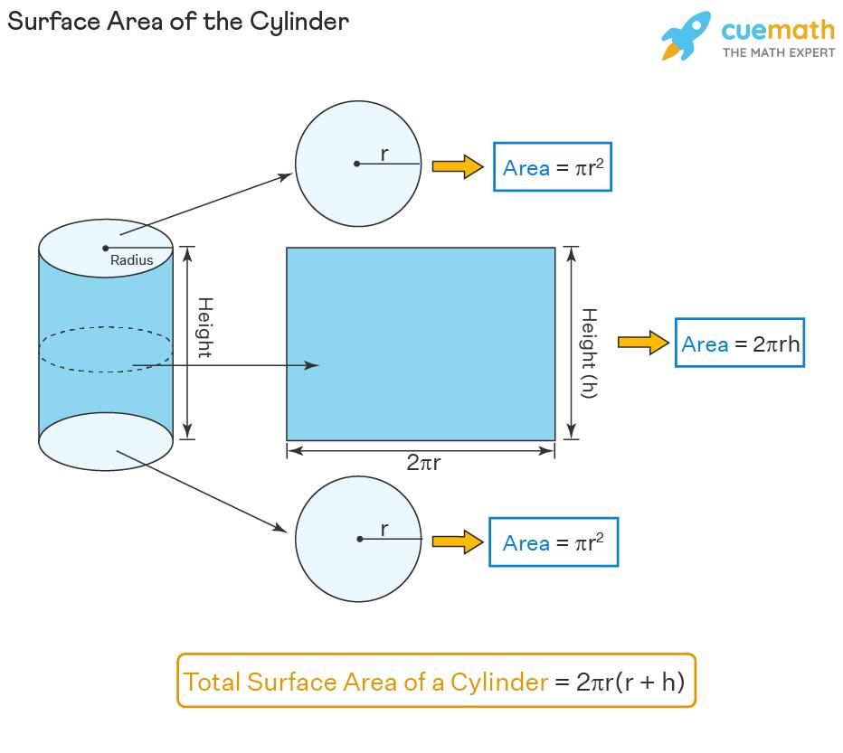
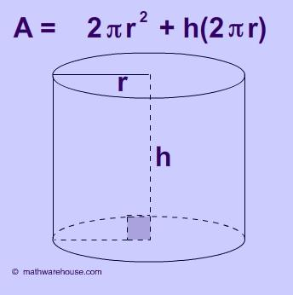
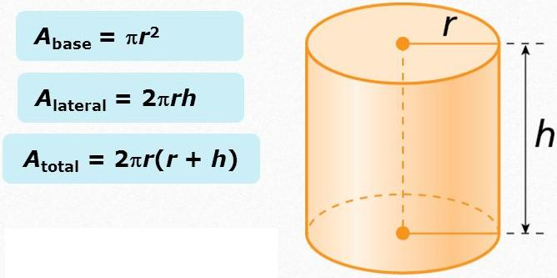
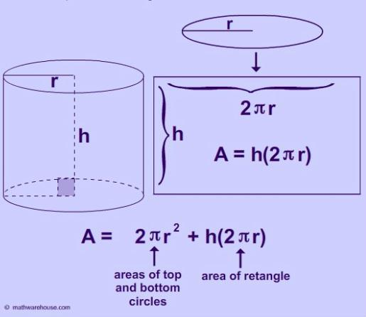
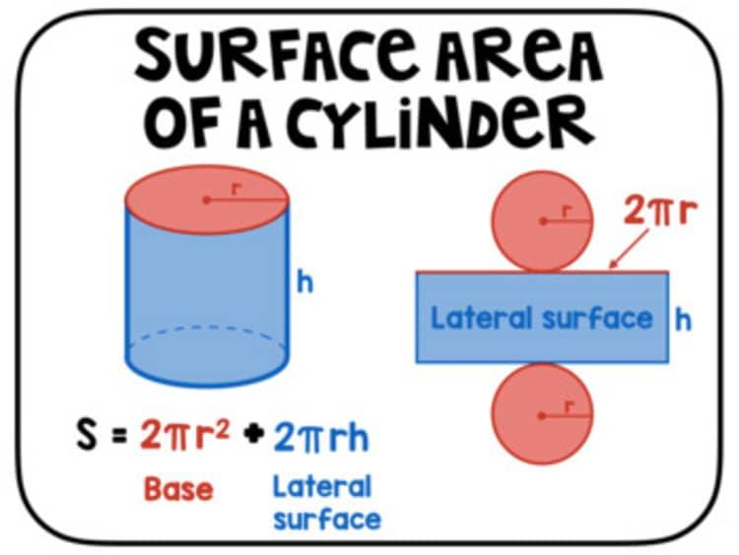
Therefore:
$$\boxed{SA=LA+2\left(\text{Base Area}\right)}$$

4. Cone
# Source: AI Source: Provided by: [Data Path: Persons Table -> ID Column: 1, Name_En Column: Motasem Essam] -> From: [ChatGPT] on [7/20/2026]
For radius $r$ and slant height $l$:
$$\boxed{SA=πr^{2}+πrl}$$
where:
- $πr^{2}$ = base area
- $πrl$ = lateral area
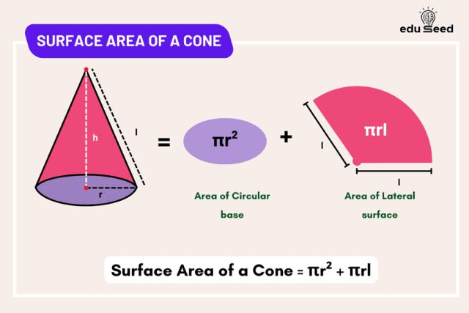
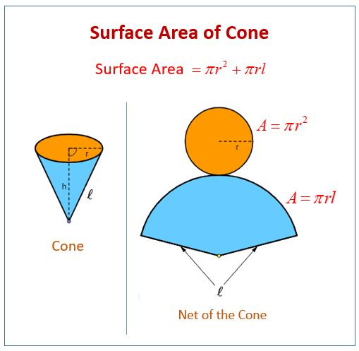
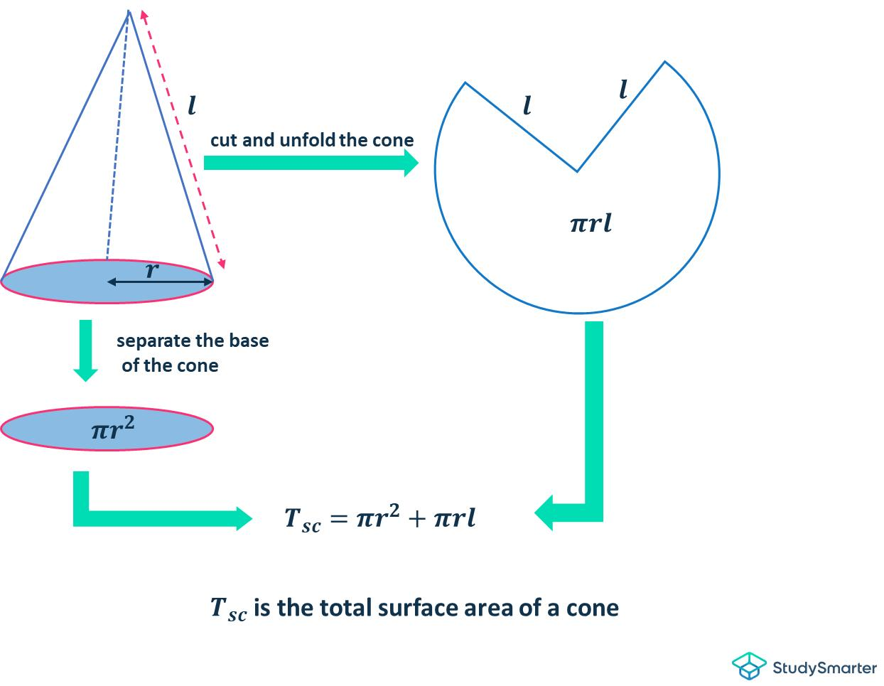
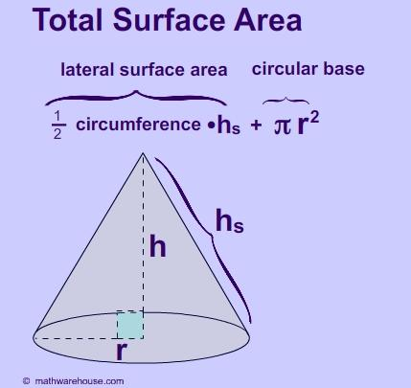
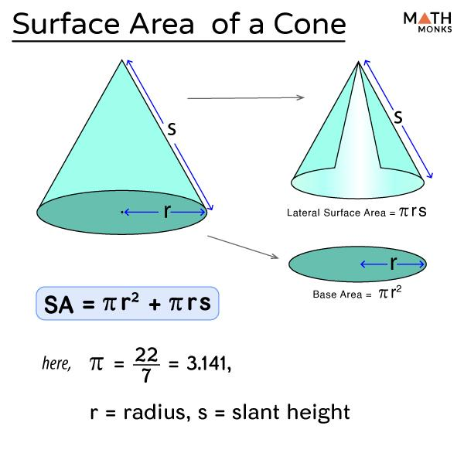

5. Regular Pyramid
# Source: AI Source: Provided by: [Data Path: Persons Table -> ID Column: 1, Name_En Column: Motasem Essam] -> From: [ChatGPT] on [7/20/2026]
For base perimeter $P$, base area $B$, and slant height $l$:
$$\boxed{SA=B+\frac{1}{2}Pl}$$
where:
$$\frac{1}{2}Pl$$
is the lateral area.

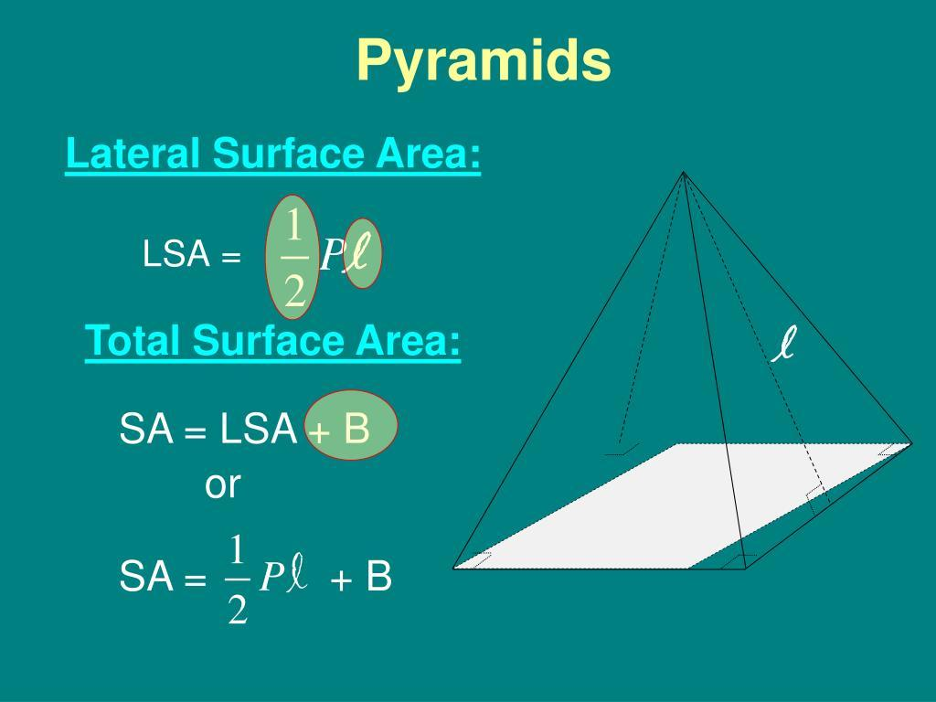
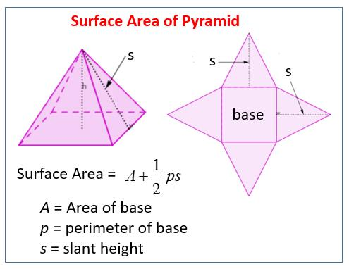
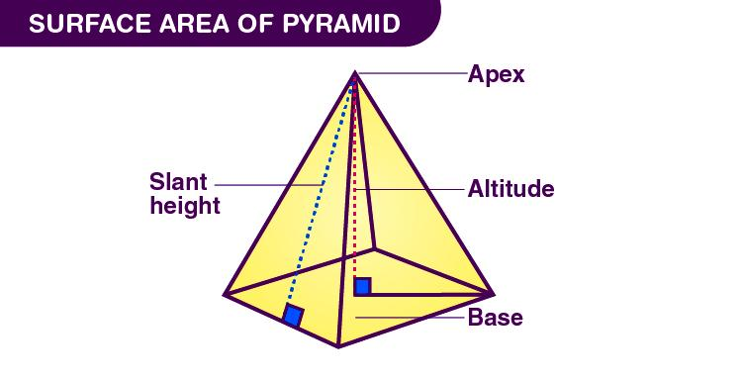
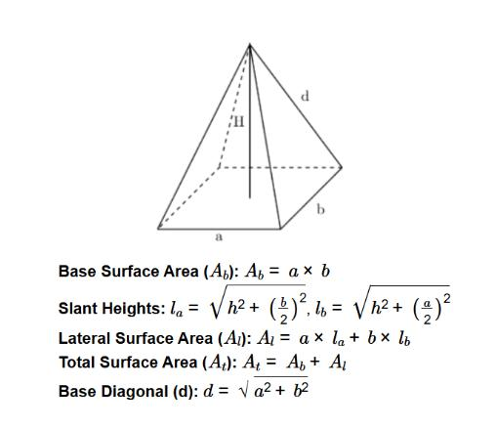

6. Sphere
# Source: AI Source: Provided by: [Data Path: Persons Table -> ID Column: 1, Name_En Column: Motasem Essam] -> From: [ChatGPT] on [7/20/2026]
A sphere has one continuous external surface and no separate bases.
$$\boxed{SA=4πr^{2}}$$
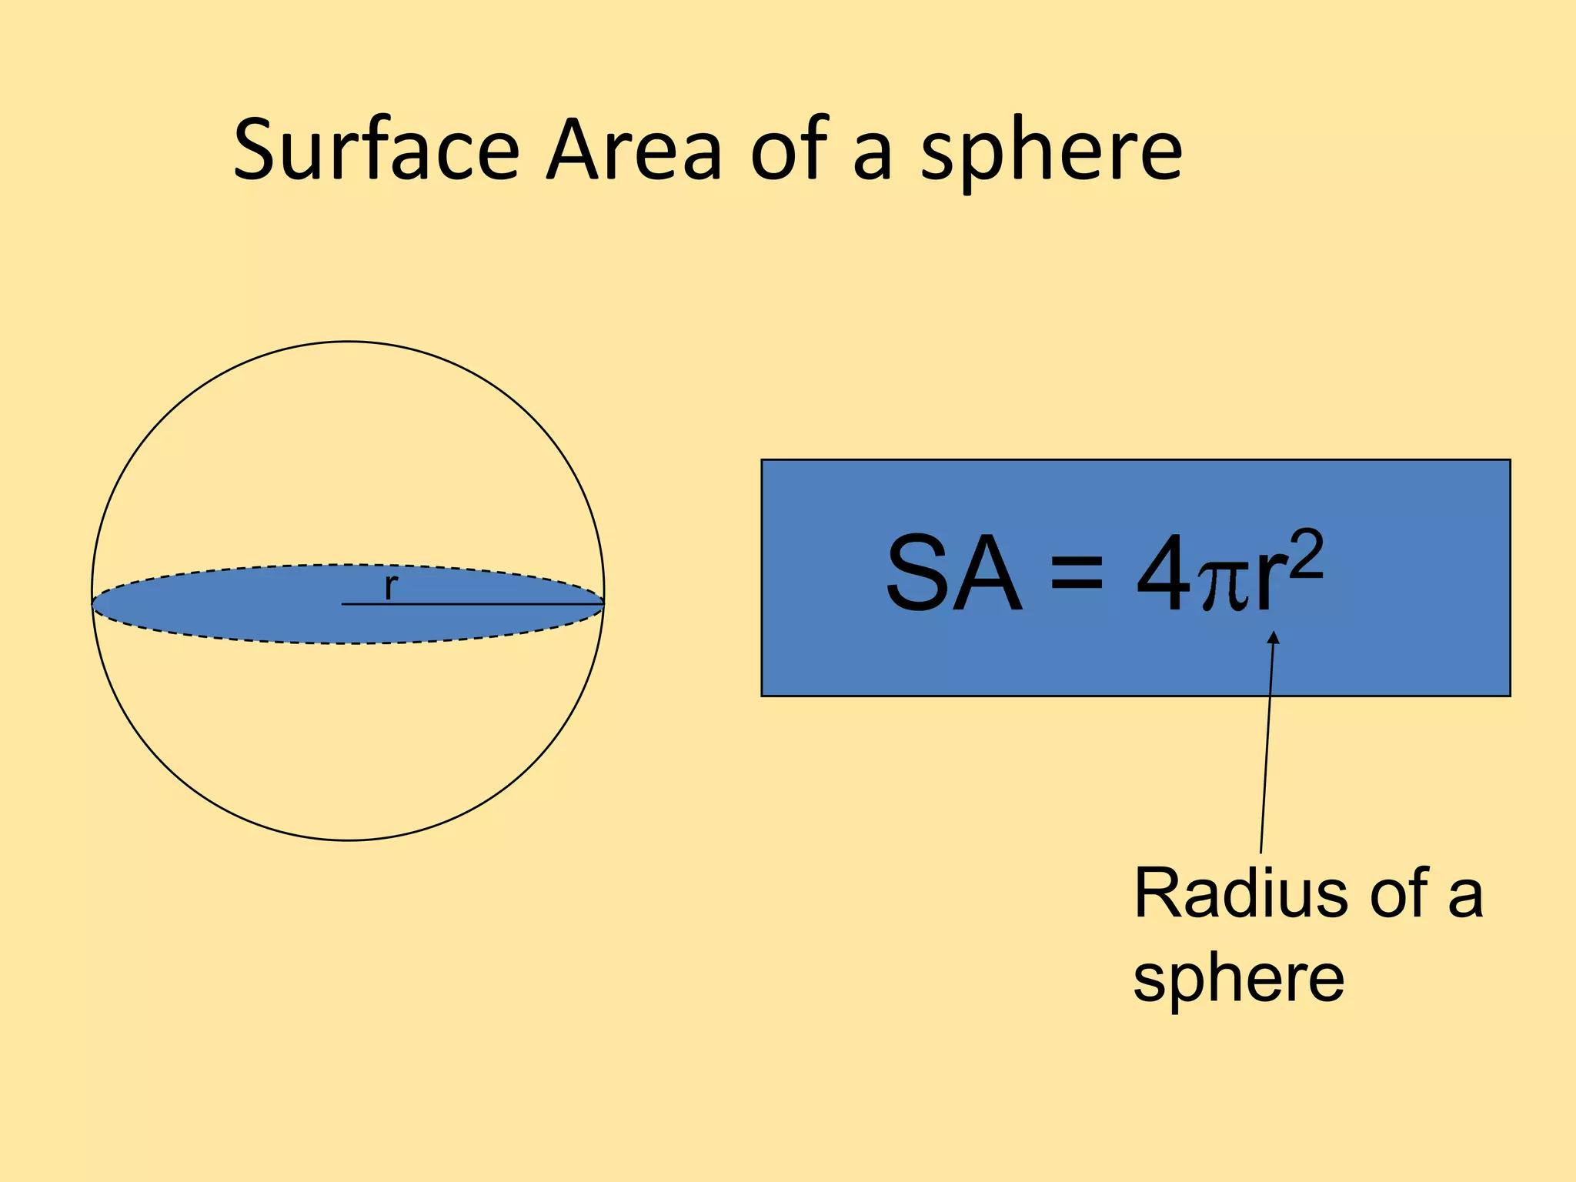
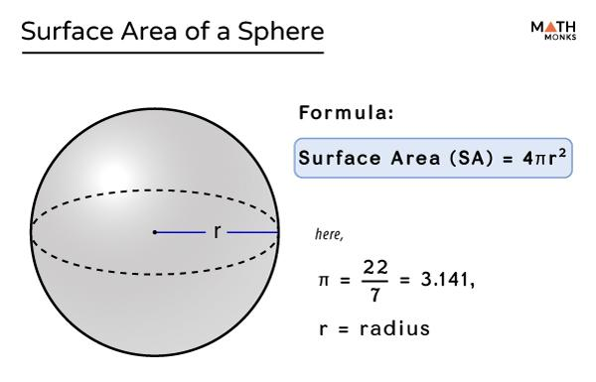
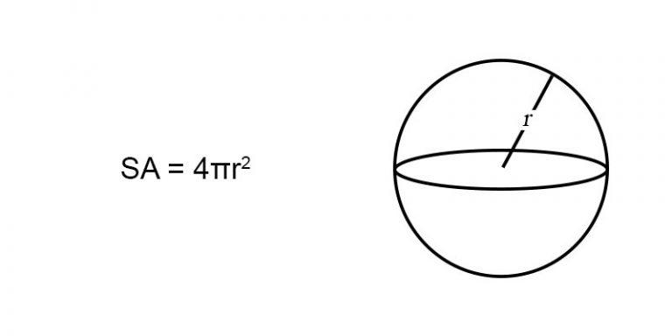
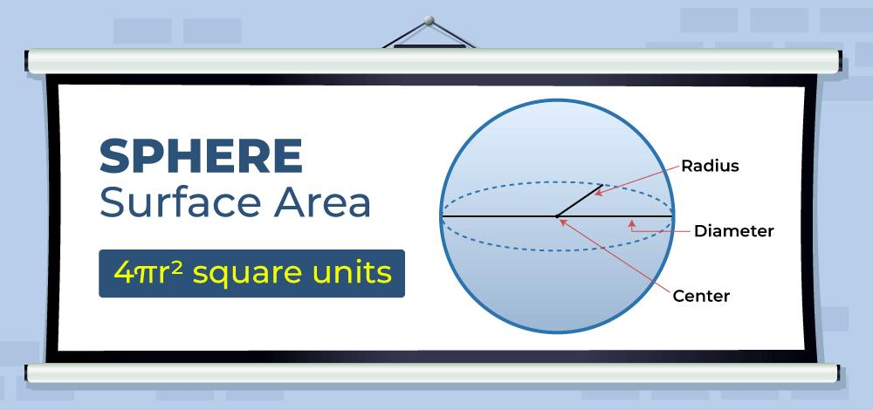

Total Surface Area vs. Lateral Area
# Source: AI Source: Provided by: [Data Path: Persons Table -> ID Column: 1, Name_En Column: Motasem Essam] -> From: [ChatGPT] on [7/20/2026]
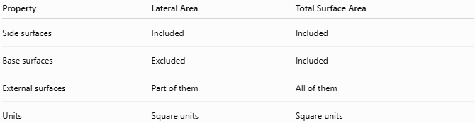
Property | Lateral Area | Total Surface Area
Side surfaces | Included | Included
Base surfaces | Excluded | Included
External surfaces | Part of them | All of them
Units | Square units | Square units
Therefore:
$$\boxed{SA=LA+\text{Base Area(s)}}$$

Total Surface Area vs. Volume
# Source: AI Source: Provided by: [Data Path: Persons Table -> ID Column: 1, Name_En Column: Motasem Essam] -> From: [ChatGPT] on [7/20/2026]
These measure different properties.
Total Surface Area
$$\boxed{SA∼L^{2}}$$
Measured in square units.
Volume
$$\boxed{V∼L^{3}}$$
Measured in cubic units.
For a rectangular prism:
$$SA=2\left(lw+lh+wh\right)$$
while:
$$V=lwh$$
Thus:
$$\boxed{\text{Total Surface Area}≠\text{Volume}}$$

Applications
# Source: AI Source: Provided by: [Data Path: Persons Table -> ID Column: 1, Name_En Column: Motasem Essam] -> From: [ChatGPT] on [7/20/2026]
Total surface area is important in:
- Geometry
- Measurement Theory
- Engineering
- Architecture
- Construction
- Manufacturing
- Mechanical Design
- Technical Drawing
- CAD (Computer-Aided Design)
- 3D Modeling
- Packaging Design
- Materials Science
- Painting and Coating
- Heat-Transfer Analysis

Advantages
# Source: AI Source: Provided by: [Data Path: Persons Table -> ID Column: 1, Name_En Column: Motasem Essam] -> From: [ChatGPT] on [7/20/2026]
Understanding total surface area helps to:
- Measure the complete external surface of a 3D object.
- Determine the amount of material needed to cover an object.
- Calculate painting, coating, wrapping, and packaging requirements.
- Support engineering and architectural designs.
- Compare the external surface sizes of different solids.
- Support heat-transfer and surface-contact analysis.
- Improve material and manufacturing estimates.

Limitations
# Source: AI Source: Provided by: [Data Path: Persons Table -> ID Column: 1, Name_En Column: Motasem Essam] -> From: [ChatGPT] on [7/20/2026]
Total surface area:
- Applies primarily to three-dimensional objects.
- Measures only the external surface, not the internal volume.
- Is measured in square units.
- Requires all relevant surface dimensions.
- Can be difficult to calculate for irregular or complex solids.
- May require decomposition into simpler geometric surfaces.
- Does not directly describe the amount of space contained inside the object.

Key Points
# Source: AI Source: Provided by: [Data Path: Persons Table -> ID Column: 1, Name_En Column: Motasem Essam] -> From: [ChatGPT] on [7/20/2026]
$$\boxed{\text{Total Surface Area}=\text{Lateral Area}+\text{Area of Base(s)}}$$
Total surface area:
- Measures all external surfaces of a 3D solid.
- Includes lateral surfaces and bases.
- Is a two-dimensional measurement.
- Is expressed in square units.
- Is different from lateral area because lateral area excludes the bases.
- Is different from volume because volume measures the space inside a solid.

Conclusion
# Source: AI Source: Provided by: [Data Path: Persons Table -> ID Column: 1, Name_En Column: Motasem Essam] -> From: [ChatGPT] on [7/20/2026]
Total surface area is the complete area of all external surfaces of a three-dimensional solid. It includes both the lateral surfaces and all bases. It is a fundamental measurement in geometry and is widely used in engineering, architecture, construction, manufacturing, packaging, and 3D design to determine how much material is required to cover the outside of an object.
$$\boxed{\text{Total Surface Area}=\text{All External Surface Areas}}$$

